Переделать это в Python3
1)

Результат работы программы.
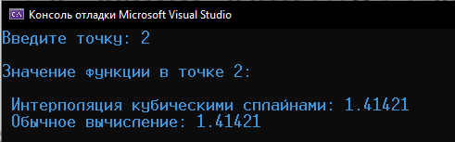

Листинг.
#include <iostream> #include <cmath> using namespace std;
const int N = 100; double F(double x)
{
return sqrt(x);
}

double* Gauss(double A[][N], double B[])
{
int i, j, k; double X[N], t, s;
for (k = 0; k < N - 1; k++)
{
for (i = k + 1; i < N; i++)
{
t = A[i][k] / A[k][k];
B[i] = B[i] - t * B[k];
for (j = 0; j < N; j++) A[i][j] = A[i][j] - t * A[k][j];
}
}
for (k = N - 1; k >= 0; k--)
{
s = 0;
for (j = k + 1; j < N; j++) s += A[k][j] * X[j];
X[k] = (B[k] - s) / A[k][k];
}
return X;
}

double Mult(int i, double X[], double Y[])
{
if (!i) return (Y[1] - Y[0]) / (X[1] - X[0]);
else

2]);

}
if (i == N - 1) return (Y[N - 1] - Y[N - 2]) / (X[N - 1] - X[N -

else return (Y[i + 1] - Y[i - 1]) / (X[i + 1] - X[i - 1]);

double* Mit(double X[], double Y[])
{
int i, j;
double A[N][N], B[N], h; for (i = 0; i < N; i++)
{
for (j = 0; j < N; j++) A[i][j] = 0;
if (!i or i == N - 1) A[i][i] = 1; else
{
A[i][i - 1] = 1;
A[i][i] = 4;

A[i][i + 1] = 1;
h = X[i] - X[i - 1];
if (i and i != N - 1) B[i] = 3 * (Y[i + 1] - Y[i - 1]) / h;
}
if (!i) B[i] = Mult(0, X, Y);
else if (i == N - 1) B[i] = Mult(N - 1, X, Y);
}
return Gauss(A, B);
}

double Spline(double x, double X[], double Y[])
{
int i;
double* M, d1, d2, d3, d4, s; M = Mit(X, Y);
for (i = 1; i < N; i++)
if (X[i - 1] <= x and x <= X[i])
{

pow(s, 3);

/ pow(s, 3);

2);

d4;
s = X[i] - X[i - 1];
d1 = (x - X[i]) * (x - X[i]) * (2 * (x - X[i - 1]) + s) /

d2 = (x - X[i - 1]) * (x - X[i - 1]) * (2 * (X[i] - x) + s)

d3 = (x - X[i]) * (x - X[i]) * (x - X[i - 1]) / pow(s, 2);
d4 = (x - X[i - 1]) * (x - X[i - 1]) * (x - X[i]) / pow(s, return Y[i - 1] * d1 + Y[i] * d2 + M[i - 1] * d3 + M[i] *

}
}

int main()
{
setlocale(LC_ALL, "Russian"); double X[N], Y[N], x;
for (int i = 0; i < N; i++)
{
X[i] = i; Y[i] = F(i);
}
do
{
cout << "Введите точку: "; cin >> x;
if (x < X[0] or x > X[N - 1]) cout << "Точка лежит вне границ
сетки!" << endl << endl;
} while (x < X[0] or x > X[N - 1]);
cout << endl << "Значение функции в точке " << x << ":" << endl << endl
<< " Интерполяция кубическими сплайнами: " << Spline(x, X, Y) << endl << "
Обычное вычисление: " << F(x) << endl;
}

2) . Скриншот работы программы
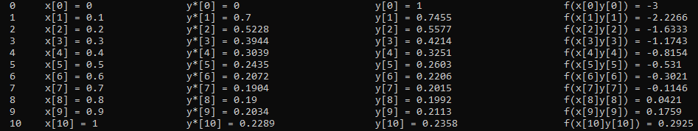

Листинг
#include <iostream>
#include <cmath>
using namespace std;

double F(double x, double y) {
return pow(x, 2) - 3 * y;
}

int main() {
double a = 0, b = 1, h = 0.1;
double n = (b - a) / h;
double* X = new double[n];
double* Y1 = new double[n];
double* Y = new double[n];
double* f = new double[n];
double* hf = new double[n];

X[0] = a;
Y[0] = 1;
Y1[0] = 0;
f[0] = F(X[0], Y[0]);

for (int i = 1; i <= n; i++) {
X[i] = a + i * h;
Y1[i] = Y[i - 1] + h * F(X[i - 1], Y[i - 1]);
Y[i] = Y[i - 1] + h * (F(X[i - 1], Y[i - 1]) + F(X[i], Y1[i])) / 2.0;
f[i] = F(X[i], Y[i]);
}

for (int i = 0; i <= n; i++) {
cout << " " << i << "\tx[" << i << "] = " << X[i] << "\t\ty*[" << i << "] = " << floor(Y1[i] * 10000) / 10000 << "\t\t\ty[" << i << "] = " << floor(Y[i] * 10000) / 10000 << "\t\t\tf(x[" << i << "]y[" << i << "]) = " << floor(f[i] * 10000) / 10000 << endl;
}
return 0;
}

